ASSIGNMENT ON

ARTIFICIAL INTELLIGENCE TOOLS

ASSIGNED BY: MR.SHUBHAM JUNEJA NAME: DIPALI SINGH

COURSE: MBA 1ST

**1.GOOGLE**

**(Audio+Text)**

**Output Input**

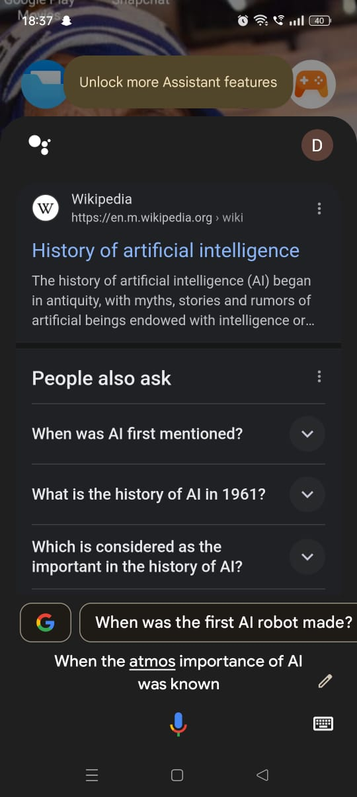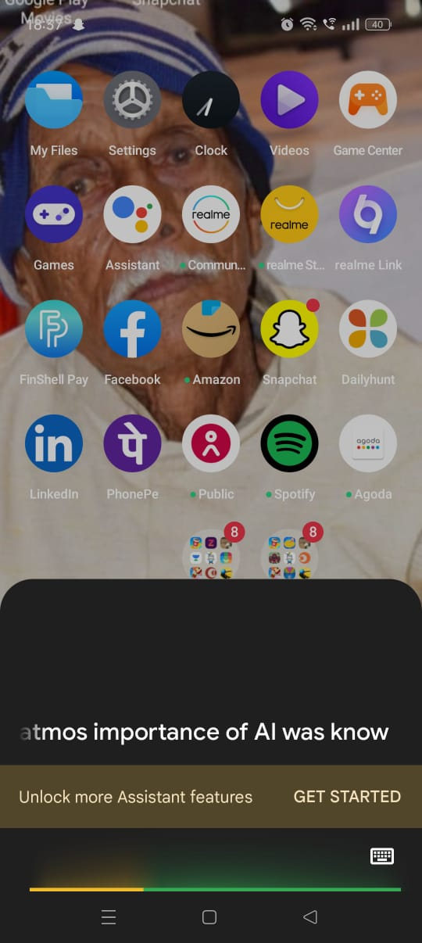

**2.CHATGPT**

**(Text+Text)**

**Output Input**

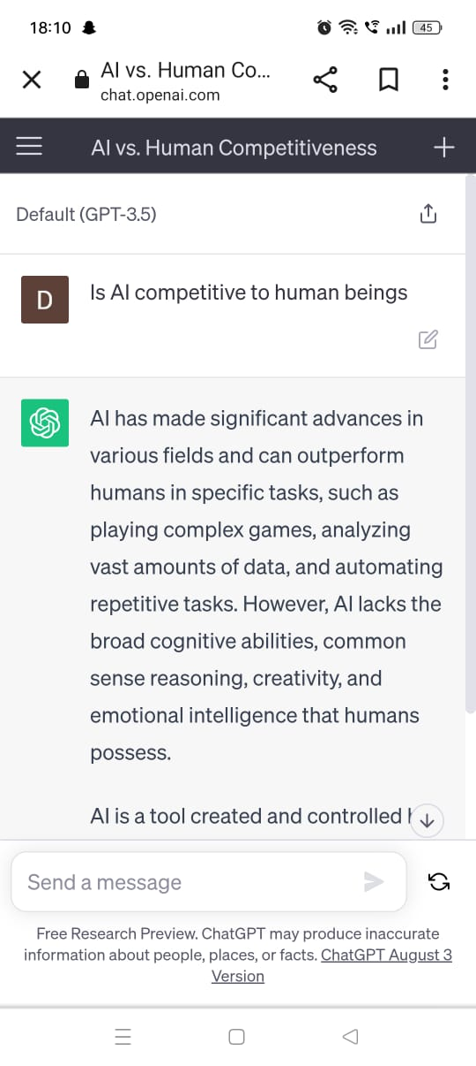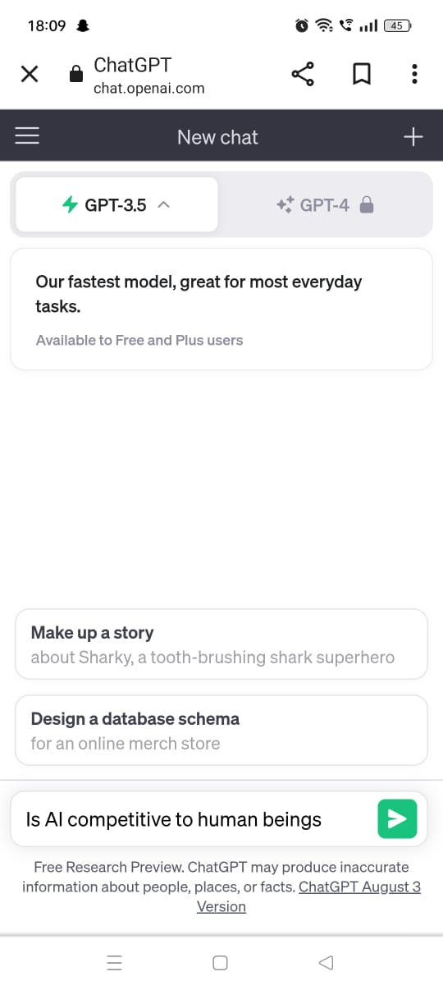

**3.FOTOR**

**(Text+Image)**

**Output Input**

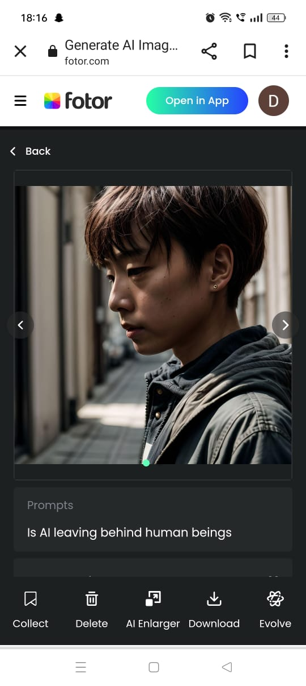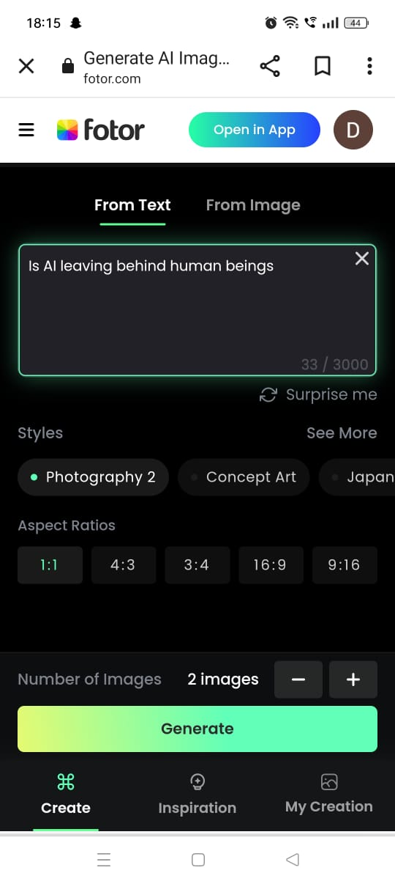

**4.MEDIUM**

**(Text+Video)**

**Output Input**



